**作业一**

**题目**

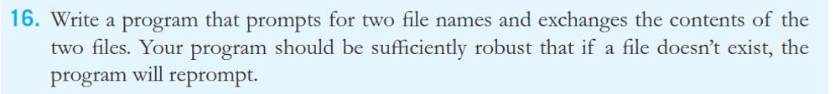

----------------------------------------------------------------------------------------------

**源代码**

txt1=input("请输入要交换的文件1的文件名:")

txt2=input("请输入要交换的文件2的文件名:")

f1=open(txt1, "r+")

f2=open(txt2, "r+")

l1=f1.read()

l2=f2.read()

#两文件光标调到开头并删掉后面所有内容

f1.seek(0)

f1.truncate()

f2.seek(0)

f2.truncate()

f1.write(l2)

f2.write(l1)

f1.close()

f2.close()

----------------------------------------------------------------------------------------------

**运行结果**

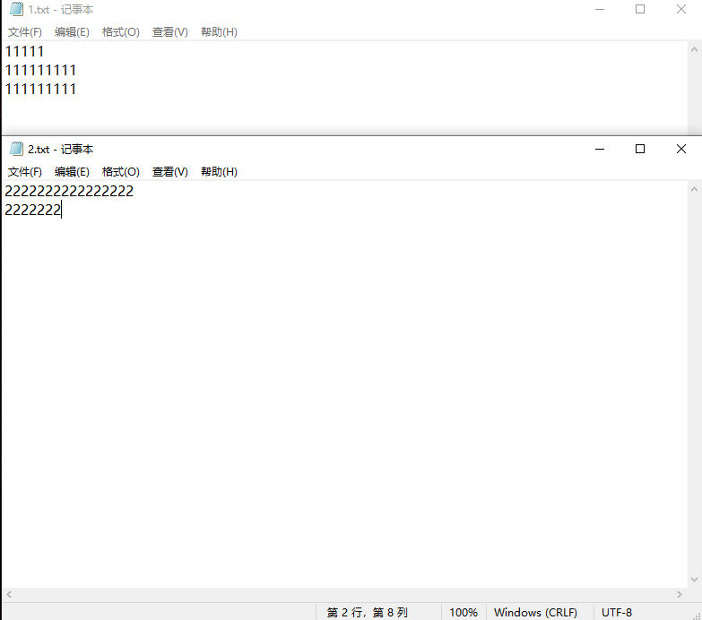

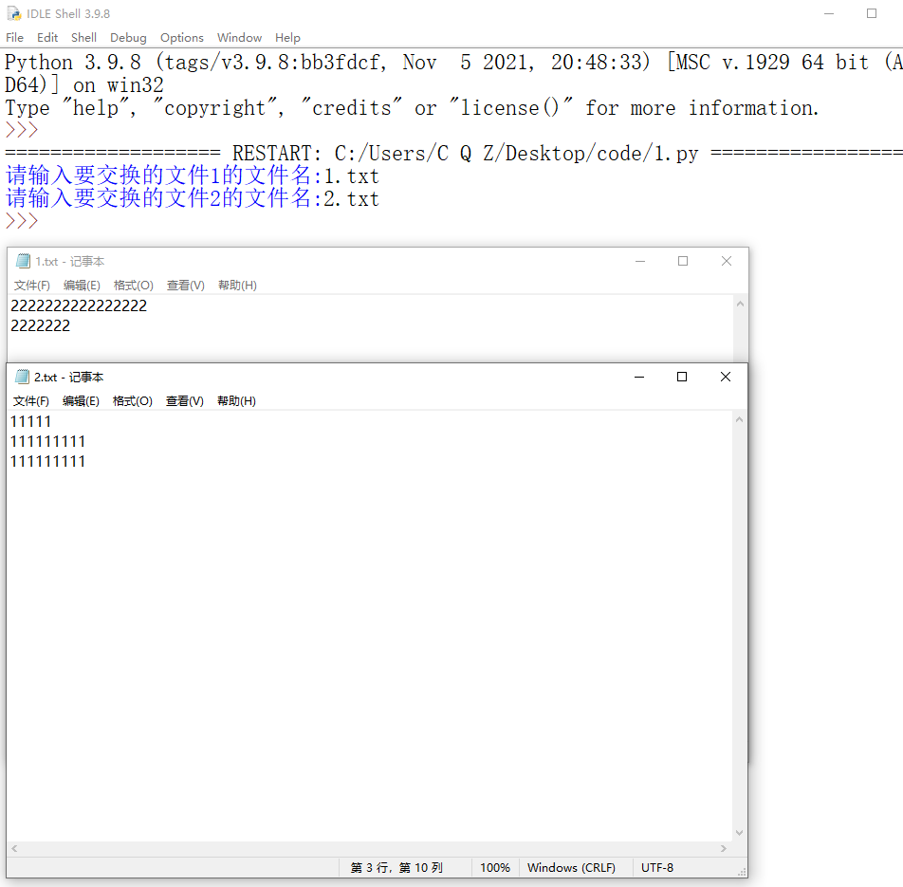

----------------------------------------------------------------------------------------------**作业二**

**题目**

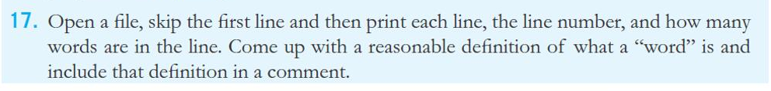

----------------------------------------------------------------------------------------------

**源代码**

fileName = input("请输入文件名:")

f = open(fileName,"r")

f.readline() #跳过第一行

lineNum = 2 #行号

line = f.readline()

while line :

    if line[0].isalpha : #开头是否是一个单词

        num=1

    else :

        num=0

    for i in range(len(line)-1) : #统计单词数

        if line[i] == " " and line[i+1].isalpha() :

            num += 1

    print("第{}行: ".format(lineNum),line,"共{}个单词".format(num))

    lineNum+=1

    line = f.readline()

----------------------------------------------------------------------------------------------

**运行结果**

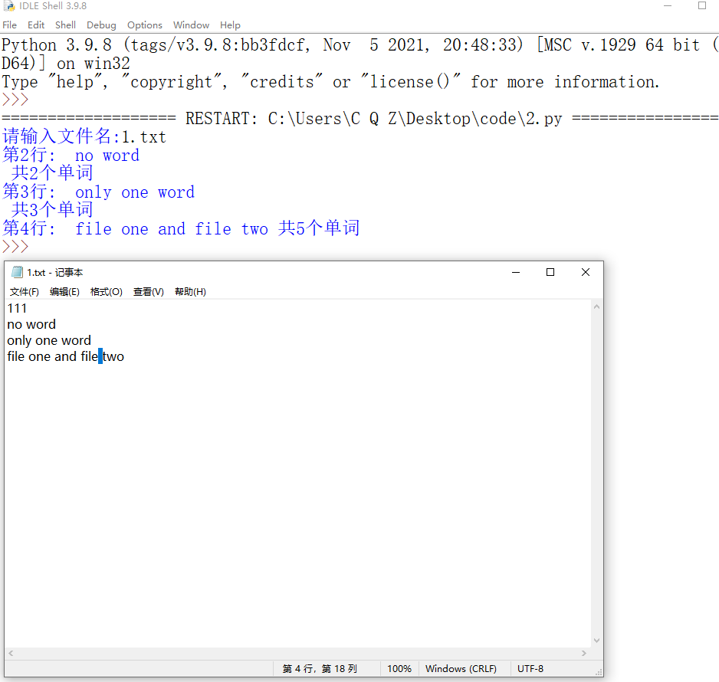

----------------------------------------------------------------------------------------------

**作业三**

**题目**

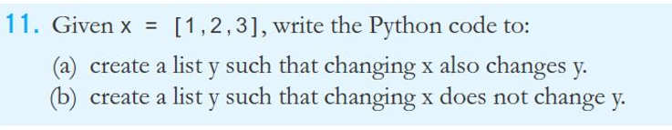

----------------------------------------------------------------------------------------------

**源代码**

import copy

def OutPut():

    print("x: ",x)

    print("y_light: ",y_light)

    print("y_oneChange: ",y_oneChange)

    print("y_deep: ",y_deep)

    print()

print("原始值复制：")

x = [1,2,3]

y_light = x #x y同时改变

y_oneChange = x.copy() # y除第一层外全改变

y_deep = copy.deepcopy(x) #互不影响

OutPut()

print("第一层加变量：")

x.append(4)

OutPut()

print("第一层加list: ")

x.append([1,2])

OutPut()

y_oneChange = x.copy() #将第一层有list的x复制下来

print("第二层改变前的y_oneChange:",y_oneChange)

print("第二层加list:")

x[4].append([3,4])

OutPut()

----------------------------------------------------------------------------------------------

**运行结果**

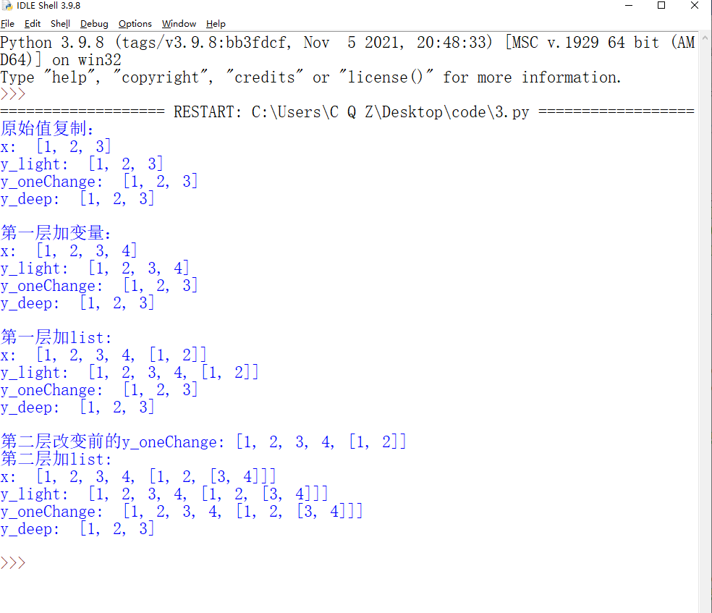

----------------------------------------------------------------------------------------------

**作业四**

**题目**



----------------------------------------------------------------------------------------------

**源代码**

L=[1,2,3,4]

print(''.join(str(i) for i in L) )

----------------------------------------------------------------------------------------------

**运行结果**



